1. **Action Menu**

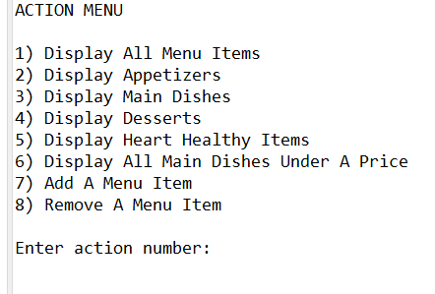When you first run the program, the program will display eight different options you can select from as shown in *Figure 1*. To select any of the options, enter the number associated with the option. For example, if you would like to see all the items on the menu, you would input the number “1” next to the prompt “Enter action number:” and press “Enter” on your keyboard. Another example would be to input the number “7” next to the prompt “Enter action number:” and press “Enter” on your keyboard if you wanted to add an item to the menu.

Figure

1. **Display All Menu Items**

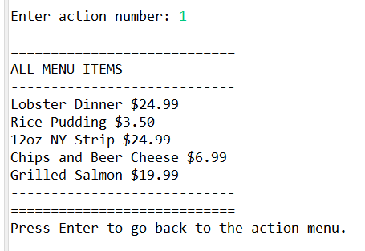If you want to see all the items on the menu, input the number “1” next to the prompt “Enter action number:” that is shown in the Action Menu and press “Enter” on your keyboard. This will display every item in the menu as shown in *Figure 2*. Press “Enter” to go back to the Action Menu.

Figure

1. **Display All Appetizers**

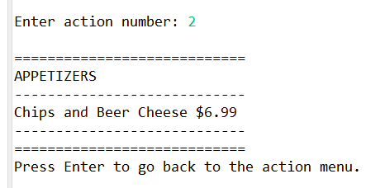If you want to see only the appetizers that are on the menu, input the number “2” next to the prompt “Enter action number:” that is shown in the Action Menu and press “Enter” on your keyboard. The program will go through each item that is currently in the menu, but only show you (the user) the menu items that are labeled as “appetizers” as shown in *Figure 3*. Press “Enter” to go back to the Action Menu.

Figure

1. **Display All Main Dishes**

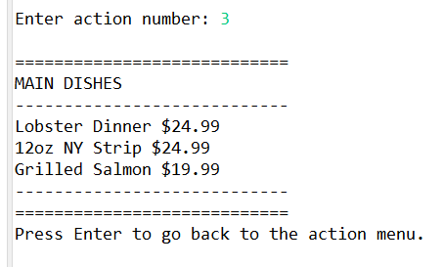Displaying all the main dishes that are currently on the menu work similarly to displaying the appetizers as discussed in section **3) Display All Appetizers**. To display all the main dishes on the menu, input the number “3” next to the prompt “Enter action number:” that is shown in the Action Menu and press “Enter” on your keyboard. The program will go through each item that is currently in the menu, but only show you (the user) the menu items that are labeled as “main dishes” as shown in *Figure 4*. Press “Enter” to go back to the Action Menu.

Figure

1. **Display All Desserts**

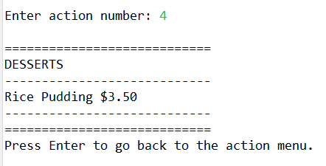Just like in sections **3) Display All Appetizers** and **4) Display All Main Dishes**, input the number “4” next to the prompt “Enter action number:” that is shown in the Action Menu and press “Enter” on your keyboard to display all the desserts that are available on the menu as shown in *Figure 5*. The program will go through each item that is currently in the menu, but only show you (the user) the menu items that are labeled as “desserts”. Press “Enter” to go back to the Action Menu.

Figure

1. **Display All Heart Healthy Items**

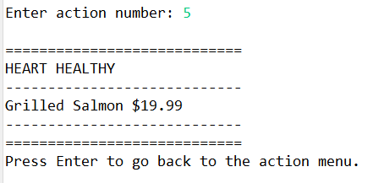To see all the heart healthy items that are currently on the menu, input the number “5” next to the prompt “Enter action number:” that is shown in the Action Menu and press “Enter” on your keyboard as shown in *Figure 6*. The program will go through each item that is currently in the menu, but only show you (the user) the menu items that are considered “heart healthy”. Press “Enter” to go back to the Action Menu.

Figure

1. **Display All Main Dishes Under A Specified Price**

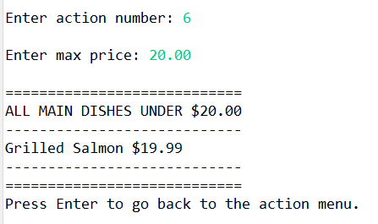To see all of the main dishes under a specified price, input the number “6” next to the prompt “Enter action number:” that is shown in the Action Menu and press “Enter’ on your keyboard. You (the user) will be shown another prompt “Enter max price:” which you should then enter a number with two decimal places (e.g. 123.45) then press “Enter” on your keyboard. In *Figure 7*, “20.00” was entered which displayed all the main dishes under $20.00.

Figure

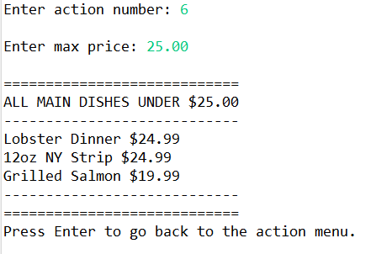In *Figure 8*, the max price of $25.00 was entered and displayed all the main dishes that are under $25.00. When you want to go back to the Action Menu, just press the “Enter” button on your keyboard.

Figure

1. **Add Menu Item**

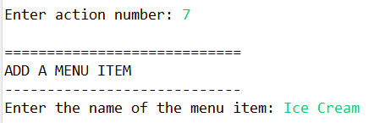To start the process of adding an item to the menu, input the number “7” next to the prompt “Enter action number:” in the Action Menu and press “Enter” on your keyboard as shown in *Figure 9*.

Figure

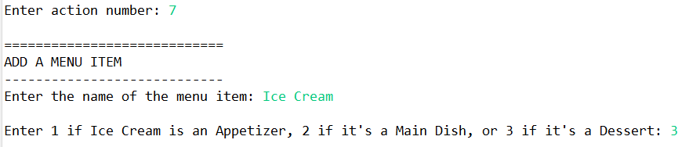Input the name of your menu item next to the prompt “Enter the name of the menu item:” and press “Enter” on your keyboard. The next prompt, “Enter 1 if [FOOD NAME] is an Appetizer, 2 if it’s a Main Dish, or 3 if it’s a Dessert:”, should appear as shown in Figure 10. If your item is an appetizer, input “1” next to the prompt. If your item is a Main Dish, input “2” next to the prompt. If your item is a Dessert, input “3” next to the prompt. Press “Enter” on your keyboard after your identified if your new menu item is either an Appetizer, Main Dish, or Dessert.

Figure : In this example, we input the number “3” to specify that “Ice Cream” is a Dessert item. If our new menu item was an Appetizer, we would input the number “1” instead. If our new menu item was a Main Dish, we would input the number “2” instead.

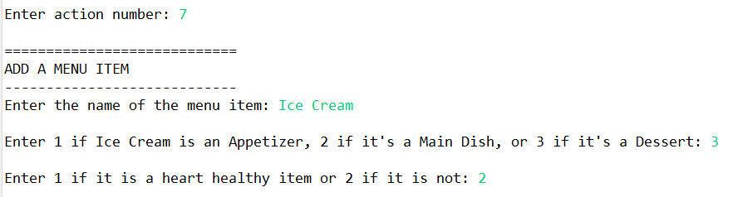

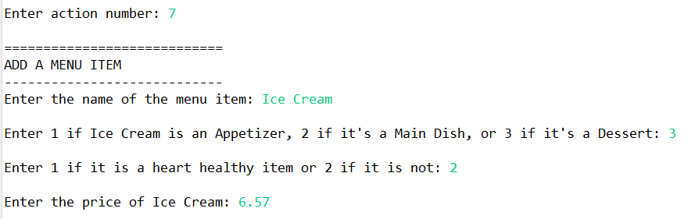After you enter the type of food your new menu item is, the next prompt, “Enter 1 if it is a heart healthy item or 2 if it is not:” will appear as shown in *Figure 11*. Next to this prompt, enter the number “1” if your new menu item IS heart healthy or the number “2” if your new menu item IS NOT heart healthy.Press “Enter” on your keyboard after you identified in the program whether your new menu item is heart healthy or not heart healthy.

Figure : In this example, we input the number “2” because Ice Cream is not a heart healthy food item. If Ice Cream were a heart healthy food item, we would have input the number “1” next to the prompt.

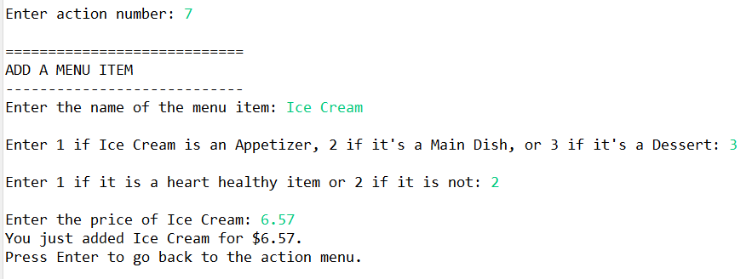After classifying the health status of your new food item, enter the price next to the next prompt “Enter the price of [FOOD NAME]:” in the format of ###0.00 where the pound (#) symbols are optional digits and the zeros (0) are mandatory digits that can be replaced by any number you choose. See *Figure 12* for an example. After you input the price, press “Enter” on your keyboard and you will get a confirmation that you have successfully added your new menu item as shown in *Figure 13*. Press “Enter” on your keyboard again to go to the action menu. Check *Figure 14* to see the new menu, “Ice Cream”, that we added.

Figure : Here, we gave Ice Cream the price of $6.57 by entering (without quotations) “6.57”. Keep in mind we could have also priced Ice Cream at $123.45 by entering “123.45” instead.

Figure

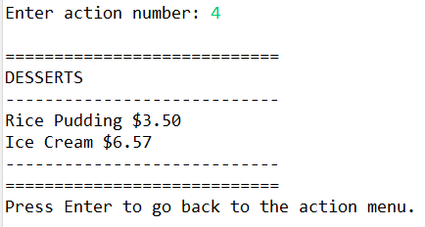

Figure : We went back to Action Menu option 4 to see our added Ice Cream!

1. **Remove Menu Item**

**check to see the exact grammar (spelling, capitalization, and spacing) of the menu item you (the user) would like to use as shown in *Figure 15*.

Figure : For this example, we will remove the Lobster Dinner. We recognize both the ‘L’ and ‘D’ are capitalized and spaces are included in the name of this menu item.

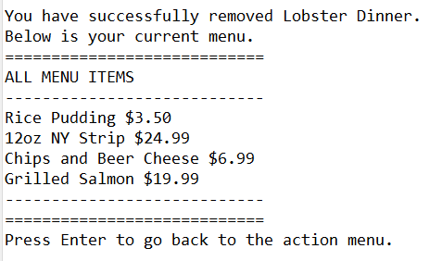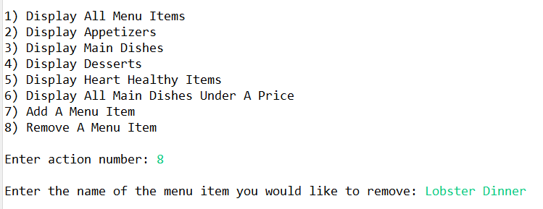

Input the number “6” next to the prompt “Enter action number:” that is shown in the Action Menu and press “Enter’ on your keyboard.

You will then be prompted to enter the name of the menu item you wish to remove. What you input MUST match the same exact format as the name of the food item you want to remove. See *Figure 16* for an example. Press “Enter” on your keyboard.

Figure 16: If we were to enter any other grammar format of “Lobster Dinner” such as “lobster dinner” or “Lobster dinner”, the food item (Lobster Dinner) we want to remove would continue to stay on the menu.

You will then see a confirmation that your specified food item has been removed and will be presented the current menu as shown in *Figure 17*. Press “Enter” on your keyboard to go back to the Action Menu.

**NOTE:** If you incorrectly formatted the name of the food item you wish to remove, the program will still contain and show that food item when you continue to run the program even though it said “You have successfully removed [FOOD NAME].” **Example:** If you wanted to remove a food item that is named “Chicken Tenders” in the program, you must input the name “Chicken Tenders” instead of any other variation of that name (e.g. “chicken tenders”). If you did enter “chicken tenders”, then the menu item “Chicken Tenders” would still be in the menu even though it said “You have successfully removed chicken tenders.”

Figure 17